AI510 Programming Exercise 07 – NGINX

Summer 2024 by Verónica Elze

## Step 2 pe_config.yaml

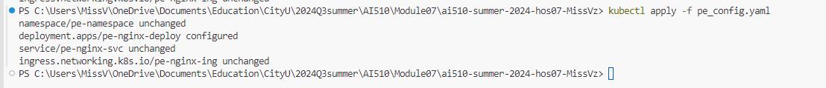

## Step 3 <http://localhost/pe-app>

Submission Steps:

1. <https://github.com/MissVz/ai510/tree/c4ec3f97c07b28ab0a7607bb8bf83e4ddc95edbd/Module07/ai510Module07>
2. Deploying a prebuilt NGINX container with minor YAML configuration changes is useful for setting up a local web application backend. It simplifies deployment and allows for easy customization and scalability.
3. 